***TITLE***

*AUTHORS*

*AFFILIATION and ADDRESS*

*Corresponding email:* [*alexis.rusinek@univ-xxxxx.fr*](mailto:alexis.rusinek@univ-xxxxx.fr)

**Abstract:**

Text for abstract using this police size and recommendations

 (1)

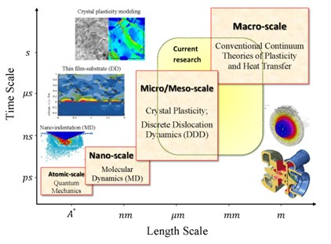

*Fig. 1. Description*

***References***

[1] F. D. Fischer, Q.-P. Sun, K. Tanaka, Transformation-Induced Plasticity (TRIP), *Appl. Mech. Rev*, **49** (1996), pp. 317–364

***MAXIMUM 2 PAGES***